Misleading Statistics

1. Write down what could be misleading about the graph below:

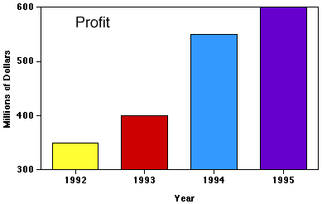

- Below is a map illustrating all recorded shark attacks between 1580 and 2006.

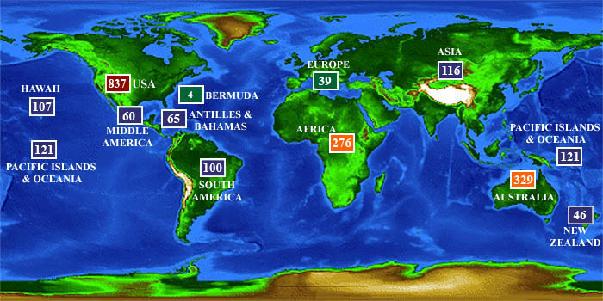

a. Which area has had the most shark attacks?
b. Which area has had the fewest shark attacks?
c. What are some factors that could affect shark attack statistics?
d. Is the map misleading in any way?

3. Carpenters in Country A are paid halve of what carpenters in Country B are paid. This is illustrated in the picture below:
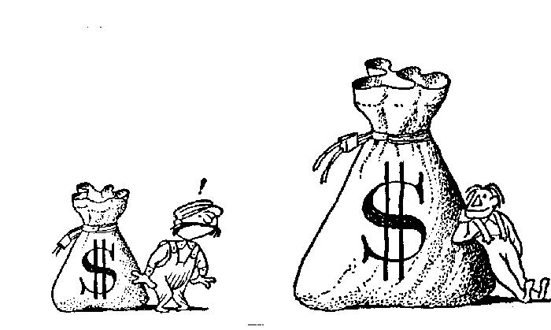

Is this picture a correct pictorial representation of the fact above?

